**PRACTICAL – (11)**

**AIM: Develop programs to understand the working of exception handling with the user guessing a number until he/she gets it right.**

**Program:**

import sys

randomList = ['a', 0, 2]

for entry in randomList:

try:

print("The Entry is", entry)

f = 1/int(entry)

break

except:

print("Ooops!", sys.exc_info()[0], " occured")

print("Next entry")

print()

print("The Reciprocal of", entry, " is", f)

print("\n20DCE019 - Yatharth Chauhan")

**OUTPUT:**

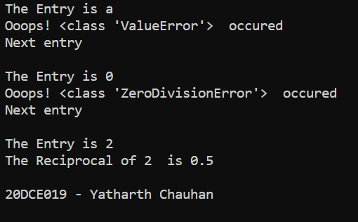

**CONCLUSION:** In this practical, we learned to handle exception in python program.